Synthesis of ionones on solid Brønsted acid catalysts
V.K. Diez, J.I. Di Cosimo, C.R. Apesteguía
Catalysis Science and Engineering Research Group (GICIC), INCAPE, UNL-CONICET.
Sgo. del Estero 2654, (3000) Santa Fe, Argentina. Email: capesteg@fiq.unl.edu.ar

Ionone isomers (α-, β- and γ-ionone) are fine chemicals widely used as pharmaceuticals and fragrances. The commercial synthesis of ionone isomers from cyclization of pseudoionones is catalyzed by liquid acids, which entails environmental concerns because of corrosion and waste disposal. Then, new industrial strategies for ionone synthesis from pseudoionone cyclization demand the replacement of liquid acids by solid catalysts. However, very few papers have been published on the use of solid acids for converting pseudoionone to ionone isomers [1].
In this work, we prepared solid Brønsted acid catalysts, namely resin Amberlyst 35W, SiO₂-supported heteropolyacid (HPA) and SiO₂-supported triflic acid (TFA), with the aim of correlating the catalyst acid site strength with the resulting ionone isomer distribution. Catalyst activity depended on the surface acid site strength so that the initial activity order for obtaining ionones was TFA > Amberlyst 35W ≈ HPA. The pseudoionone molecule is initially activated on surface Brønsted acid sites and forms a common cyclic intermediate for the consecutive ionone isomer generation. This cyclic carbocation intermediate contains three different kinds of protons that upon direct detachment lead to α-, β- or γ-ionones as primary products. Selectivity to the three ionone isomers was also strongly dependent on the acid site strength. Under initial conditions, pseudoionone transformation gave ionone mixtures with approximately statistical composition (40% α-ionone, 20% β-ionone and 40% γ-ionone), regardless of catalyst Brønsted acid site strength. However, with the progress of the reaction γ-ionone, the least stable isomer, was isomerized to α-ionone on HPA and Amberlyst 35W, and to β-ionone on the stronger acid sites of TFA (Figure 1). Therefore, binary mixtures of α- and β-ionone can be obtained by properly selecting operational conditions since the kinetics of ionone isomer interconversion may be controlled by changing the Brønsted acid site strength, temperature and reaction time.
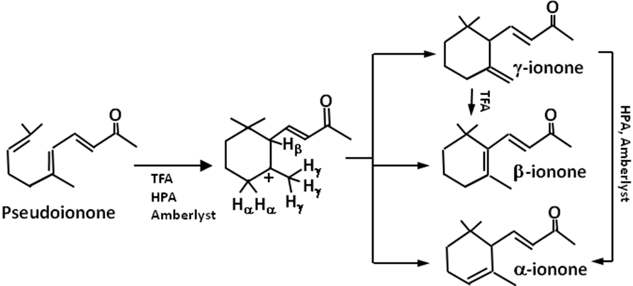

Figure 1: Synthesis of ionone isomers from pseudoionone on Brønsted acid catalysts

1. V.K. Díez, B.J. Marcos, C.R. Apesteguía, J.I. Di Cosimo, Applied Catalysis A: General 2009, 358, 95.

