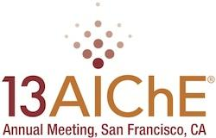

Highlights

IACChE's James Y. Oldshue Lecture
Tuesday, November 5, 2013, 8:30am-11:00am PST
Hilton San Francisco Union Square, Grand Ballroom A
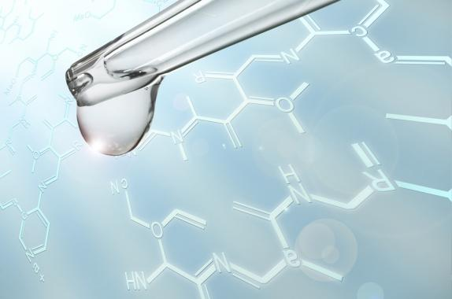

Synthesis of Fine Chemicals by Heterogeneous Catalysis: A Critical Approach of the Role of Solvent for Hydrogenation Reactions
The synthesis of fine chemicals over solid catalysts often involves the use of solvents that may strongly influence the catalyst performance. Thus, the choice of suitable solvents is frequently critical to obtain high catalytic activity and selectivity. However, the optimal solvent selection requires a detailed knowledge on the relationship between the chemical nature of the solvents and the interactions taking place in the gas-liquid-solid catalytic systems. One of the most common types of catalytic reactions carried out in the presence of solvents is the hydrogenation of organic compounds. In particular, the selective hydrogenation of aromatic ketones into the corresponding alcohols on metal-based catalysts in the presence of different solvents has been widely studied. Here, the solvent effect on catalyst activity and selectivity for the liquid-phase hydrogenation of acetophenone to 1-phenylethanol was thoroughly investigated over Ni/SiO₂. Solvents of different properties and polarities were used: i) protic solvents: methanol, ethanol, 1-propanol and 2-propanol; ii) aprotic polar solvents: acetonitrile, g-butyrolactone and tetrahydrofuran; iii) aprotic apolar solvents: cyclohexane, toluene and benzene. The relative interactions solvent–catalyst, solvent–reactant and reactant–catalyst and their influence on the activity pattern were considered in the analysis. Concerning the influence of the solvent-reactant interaction, classical polarity parameters (e.g. dipole moment m and dielectric constant ε) and other solvatochromic scales (e.g. hydrogen-bond donor (a) and hydrogen-bond acceptor (b) parameters, p* polarity/polarizability index, Kosower’s Z and ET(30) scales) were taken into account. The influence of H₂ solubility in the solvents was also considered. For the solvent-catalyst and reactant-catalyst interactions, the corresponding molar adsorption enthalpies were measured calorimetrically and compared.


Carlos R. Apesteguía
Carlos R. Apesteguía is Full Professor at the National University of Litoral (UNL), School of Chemical Engineering (FIQ), and Member of the CONICET's Research Staff at the Institute of Research on Catalysis and Petrochemistry (INCAPE), Santa Fe, Argentina. Currently, he is also the Director of the Materials Science and Engineering Research Center (CenMat, FIQ, UNL) and Chairman of the Materials Engineering Department (FIQ, UNL).

